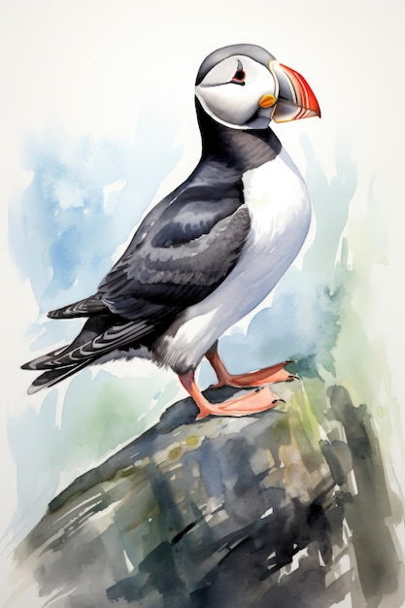**Habitat:**

Atlantic Puffins nest in burrows on rocky islands with short vegetation, and on sea cliffs. They spend the rest of the year at sea.

**Food:**

Atlantic Puffins eat small fish around 2 to 6 inches long, mainly sandlance (sandeel), sprat, capelin, herring, hake, and cod.

**Nest Placement**

Atlantic Puffins nest in colonies on small islands covered in short vegetation, typically in the turf soil at the tops of steep, rocky cliffs.

**Fun Facts:**

Atlantic Puffins spend most of their life on the open ocean, coming ashore only to breed. On land they waddle like a penguin, teetering slightly from side to side. They "fly" underwater using their wings for propulsion and their feet as a rudder. They can dive to depths of around 60 meters / 200 feet, but they typically feed in shallower waters.

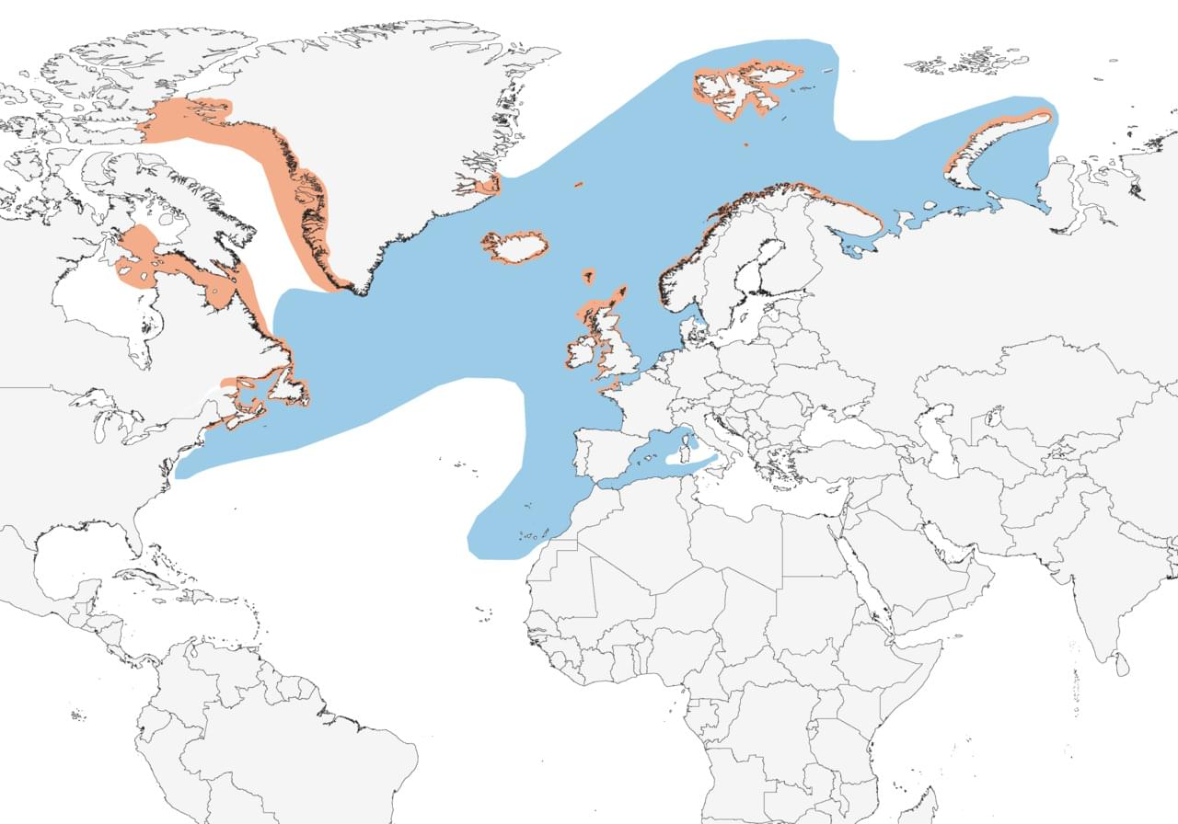

**Where?**

The best place that I have found to see the Puffins is about 50 meters / 160 feet to the right of O’Briens Tower, looking out in a North Westerly/ Noth North Westerly direction.

**Tips for Spotting the Puffins:**

Puffins are a small bird and are about the size of a pigeon so this can make them hard to spot and with the distance it will be almost impossible to see their colourful bill and orange feet with the naked eye. They are also one of the smallest seabird species at the Cliffs of Moher.

* **Flying:** Puffins will fly directly in and out of the Cliffs, they do not fly horizontally along the cliffs like the other sea bird species. They often fly lower to the water and at the last moment will pull up. They fly in stiff-winged flight and they will flap their wings a little faster than the other seabirds around.
* **Markings/ Plumage:** Puffins both male and female will be completely jet black from above, and you will not be able to see any white while in flight. When they make their approach to the Cliffs and start to bank or pull up you will see their white underbelly.
* 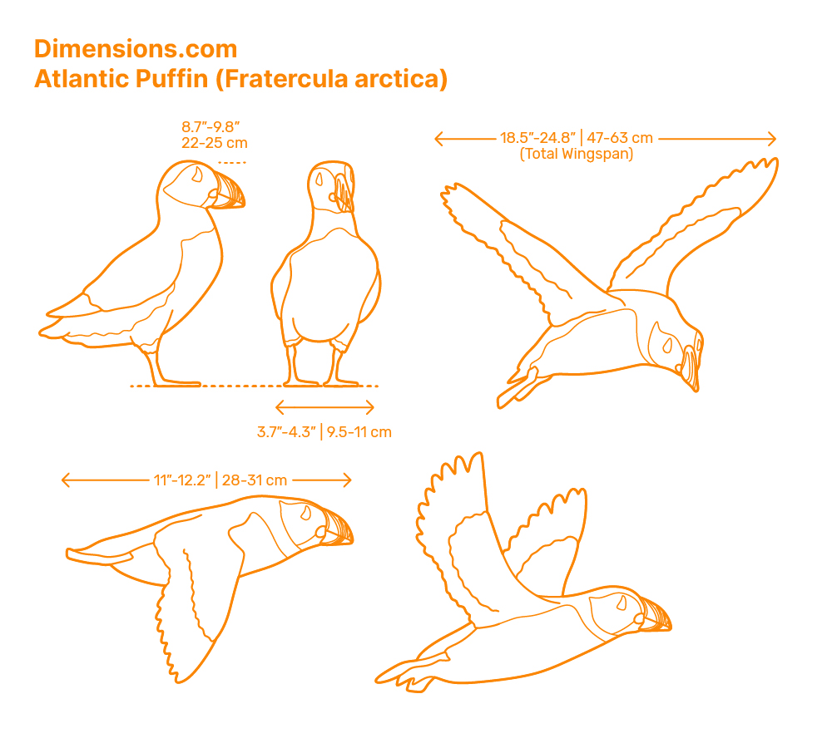**Timing:** Puffins are most active during the early morning and late evening but while breeding and rearing young they will be active throughout the day. Sometimes it might take some patience before you see them as they go out foraging in small parties of up to 7 birds and will only return when they have caught a beak full of fish. Due to the large number of Puffins at the Cliffs the most you would be waiting for spotting the puffins is about 5min.